Project Milestone 6

* Project Name: Kong Grow
* Group Members: Tyler Valentine, Charles Mezhir, Bader Albader, Jacob Tran, Garrett Senor
* Project Tracker: Trello. Link: <https://trello.com/b/f5FD39t1/kong>

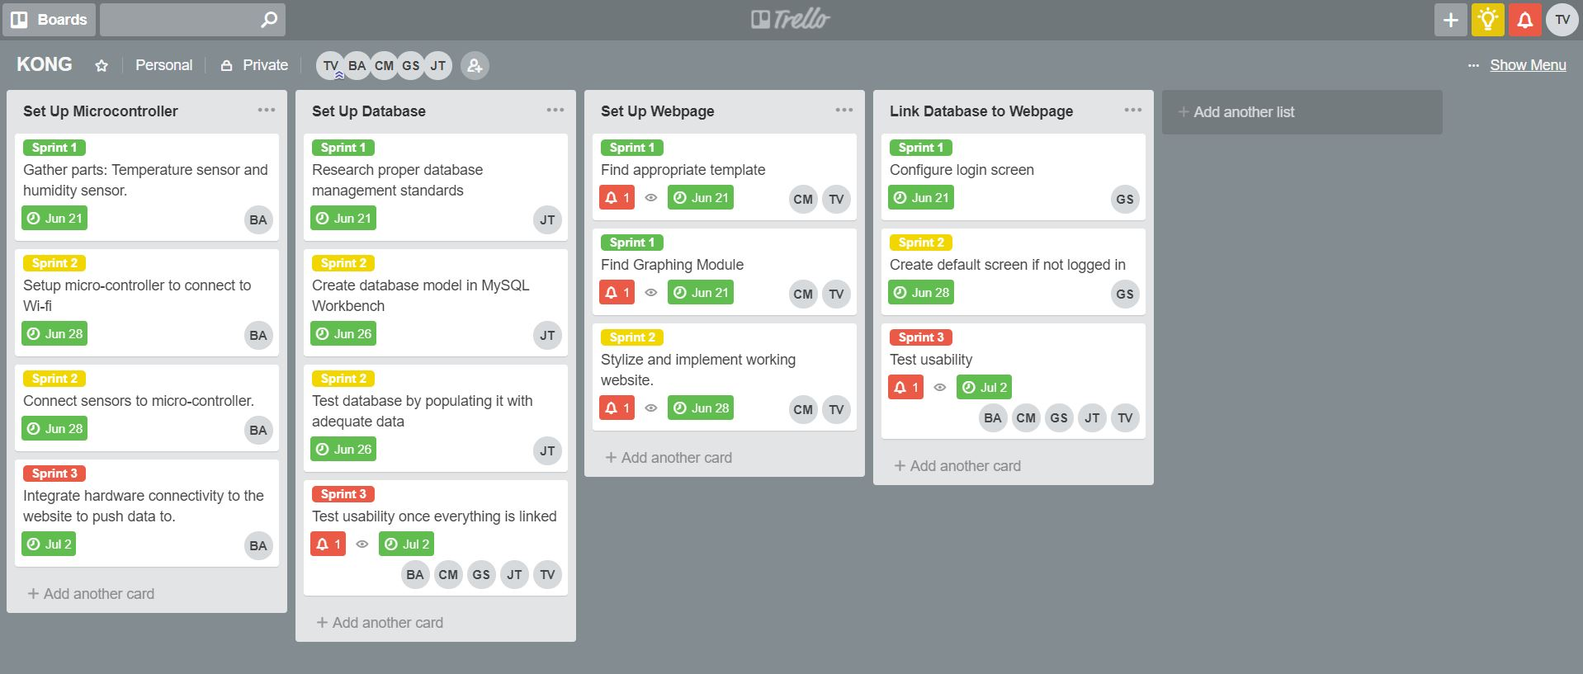

* VCS: Github. Link: <https://github.com/albader94/kong>
* Group Member Contributions:

*Insert Screenshot when all pushes are completed*

* Deployment:
* Auto Doc (Optional):